Capstone Project Document
For
The AI Resume Matcher

Contents
Abstract 3
1. Introduction 3
2. Problem Statement 4
3. Project Objectives 4
4. System Architecture 5
5. Technologies Used 7
6. System Workflow 8
7. AI Analysis Pipeline 8
8. Deployment on AWS Elastic Beanstalk 9
9. Advantages of the System 10
10. Future Enhancements 11
11. Conclusion 11

Abstract
Recruitment is one of the most critical processes for organizations. Traditional recruitment methods rely heavily on manual resume screening, which is time-consuming and inefficient. Recruiters often need to review hundreds of resumes manually, which increases the chances of overlooking qualified candidates.
This capstone project presents an AI Resume Matcher System that automatically analyzes candidate resumes and compares them with job descriptions using Artificial Intelligence. The system extracts relevant skills from resumes, evaluates candidate qualifications, and generates match scores along with hiring recommendations.
The system is developed using FastAPI for backend services, HTML and JavaScript for frontend development, and Google Gemini AI for intelligent resume analysis. The application is deployed on AWS Elastic Beanstalk, which enables cloud hosting and provides a live web URL.
The proposed system significantly improves recruitment efficiency by automating resume analysis, reducing manual effort, and enabling intelligent candidate evaluation.

1. Introduction
Recruitment plays a vital role in the success of any organization. Companies receive a large number of job applications for each position, which makes it difficult for recruiters to manually analyze every resume.
Traditional recruitment systems mainly rely on keyword-based filtering or manual screening. These approaches have several limitations:
- Lack of contextual understanding of candidate experience
- Difficulty identifying transferable skills
- High time consumption
- Inconsistent hiring decisions
With advancements in Artificial Intelligence (AI) and Natural Language Processing (NLP), it is now possible to automatically analyze resumes and match them with job requirements.
The AI Resume Matcher System was developed to address these challenges. The system uses AI models to analyze resumes, extract relevant skills, and compare them with job descriptions.

The system generates the following outputs:
- Candidate Match Score
- Skill Gap Analysis
- Candidate Strengths
- Hiring Recommendation
This automation helps recruiters identify the most suitable candidates quickly and efficiently.

2. Problem Statement
Traditional recruitment systems rely on keyword matching techniques, which cannot fully understand candidate experience or skill context.
As a result:
- Recruiters spend excessive time reviewing resumes manually.
- Qualified candidates may be overlooked.
- Hiring decisions may become inconsistent.
- Recruitment efficiency decreases.
Therefore, there is a need for an AI-powered recruitment system that can intelligently analyze resumes and match them with job descriptions.

3. Project Objectives
The objectives of this project are:
- To design an AI-powered resume matching system.
- To automatically compare candidate resumes with job descriptions.
- To generate candidate match scores.
- To identify candidate strengths and missing skills.
- To provide AI-based hiring recommendations.
- To deploy the system on AWS Cloud infrastructure.

4. System Architecture
The AI Resume Matcher follows a modern full-stack architecture consisting of three major components:
- Frontend Layer
- Backend Layer
- AI Engine
Frontend
The frontend provides the user interface where recruiters can upload resumes and job descriptions.
Technologies used:
- HTML5
- JavaScript
- Tailwind CSS
Key Features:
- Resume upload
- Job description upload
- Candidate ranking display
- Skill gap analysis visualization

Backend
The backend is developed using FastAPI, a modern Python web framework.
Responsibilities:
- Handle API requests
- Accept resume uploads
- Process job descriptions
- Communicate with AI engine
- Return structured results

Example backend initialization code:
from fastapi import FastAPI, Request
from fastapi.templating import Jinja2Templates
from fastapi.staticfiles import StaticFiles
import os
app = FastAPI(title="AI Resume Matcher API")
frontend_dir = os.path.join(os.path.dirname(__file__), "frontend")
templates = Jinja2Templates(directory=frontend_dir)
app.mount("/static", StaticFiles(directory=os.path.join(frontend_dir, "static")), name="static")
@app.get("/")
async def read_root(request: Request):
return templates.TemplateResponse("index.html", {"request": request})

AI Engine
The AI engine uses Google Gemini AI to analyze resume content.
Key tasks performed:
- Resume text extraction
- Job description analysis
- Skill comparison
- Match score generation

System Architecture Diagram
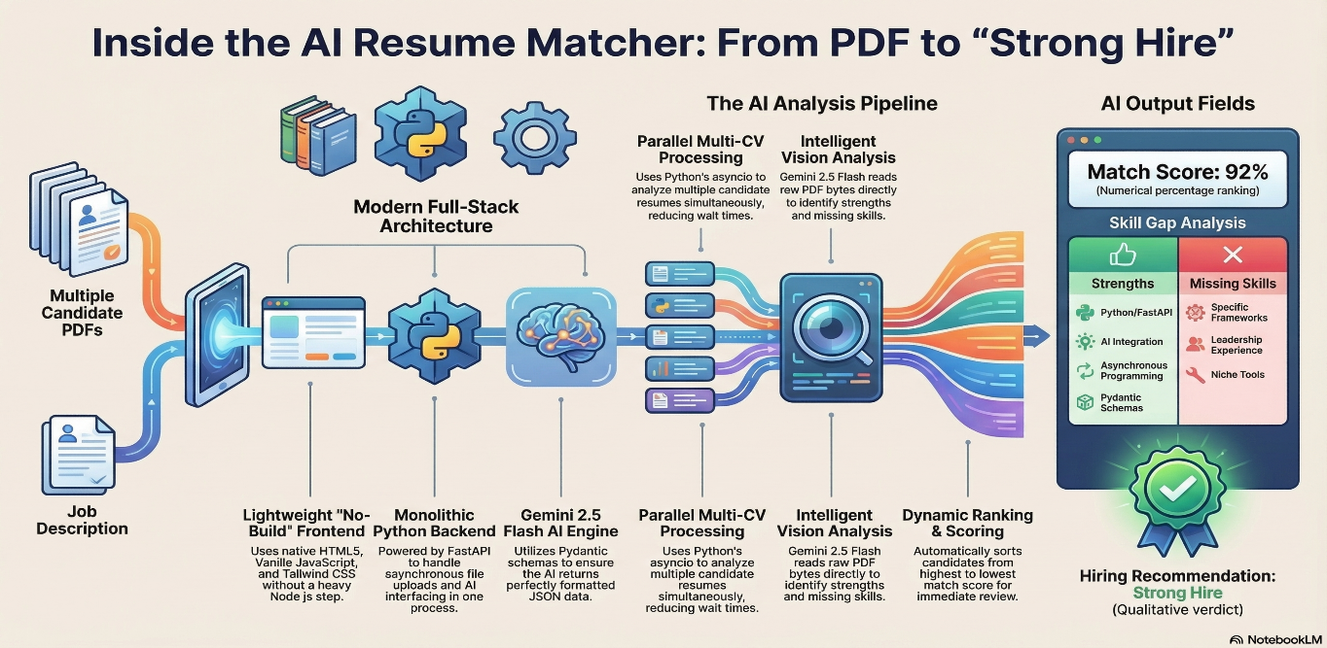
Figure 4.1: Architecture and processing pipeline of the AI Resume Matcher system
The system processes candidate resumes and job descriptions through an AI analysis pipeline. The FastAPI backend sends the document data to the Gemini AI engine, which extracts relevant skills and generates candidate evaluation metrics.

5. Technologies Used
Technology | Purpose
Python | Backend programming language
FastAPI | Backend API framework
HTML5 | Frontend structure
JavaScript | User interaction
Tailwind CSS | UI design
Google Gemini AI | Resume analysis
Pydantic | Data validation
Uvicorn | Application server
AWS Elastic Beanstalk | Cloud deployment

6. System Workflow
The workflow of the AI Resume Matcher system is as follows:
- Recruiter uploads job description.
- Recruiter uploads candidate resumes.
- Backend receives files via FastAPI API.
- Resume text is extracted.
- Gemini AI analyzes resume content.
- Skills are extracted and compared with job requirements.
- Match scores are generated.
- Candidates are ranked.
- Hiring recommendations are displayed.

7. AI Analysis Pipeline
The AI engine performs several steps:
- Resume parsing
- Skill extraction
- Experience evaluation
- Candidate ranking
Example output:
Match Score: 92%
Strengths:
- Python
- FastAPI
- AI Integration
- Asynchronous Programming

Missing Skills:
- Leadership experience
- Specific frameworks
- Niche tools
Hiring Recommendation:
Strong Hire

8. Deployment on AWS Elastic Beanstalk
The system is deployed on AWS Elastic Beanstalk, which simplifies cloud application deployment.
Deployment steps include:
- Package project files.
- Create ZIP archive.
- Login to AWS Console.
- Create Elastic Beanstalk environment.
- Select Python platform.
- Upload application ZIP file.
- Configure environment variables.
- Add Gemini API key.
- Launch application.
Deployment typically takes 3–5 minutes.

Deployment Architecture
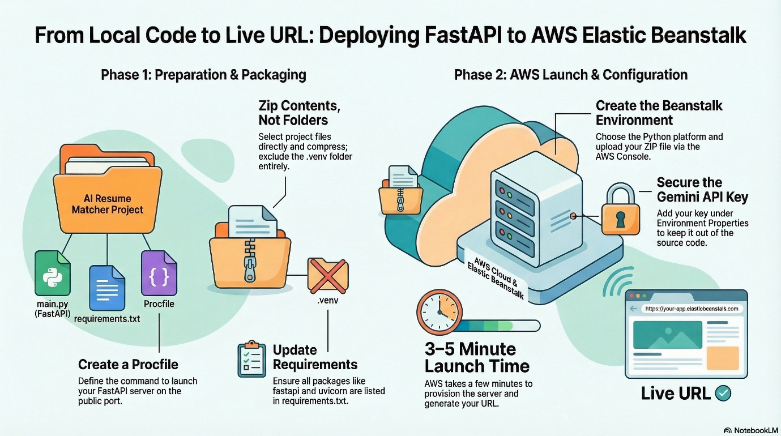
Figure 8.1: Deployment workflow of the FastAPI AI Resume Matcher system on AWS Elastic Beanstalk
The deployment process consists of preparing the project files, packaging the application, uploading it to AWS Elastic Beanstalk, and launching the environment to generate a live URL.

9. Advantages of the System
The AI Resume Matcher offers several advantages:
- Faster recruitment process
- Reduced manual resume screening
- Intelligent skill analysis
- Consistent candidate evaluation
- Scalable cloud deployment
- Improved hiring decision accuracy

10. Future Enhancements
Future improvements may include:
- Resume parsing using advanced NLP models
- Integration with LinkedIn APIs
- Support for additional document formats
- Machine learning model training for improved accuracy
- HR analytics dashboard

11. Conclusion
The AI Resume Matcher System demonstrates how Artificial Intelligence can improve recruitment processes. By automating resume analysis and comparing candidate profiles with job requirements, the system provides accurate match scores and hiring recommendations.
The integration of FastAPI, Google Gemini AI, and AWS cloud infrastructure enables the development of a scalable and intelligent recruitment platform.
The system helps organizations identify suitable candidates efficiently while reducing manual effort and improving hiring decisions.

